**Farmers Guide**

**A PROJECT REPORT**

***Submitted by***

***Nakkanaboina Surendra***

***in partial fulfillment for the award of the degree***

***of***

**BACHELOR OF TECHNOLOGY**

**IN**

**COMPUTER SCIENCE AND ENGINEERING**



**Lovely Professional University, Punjab**

**12405682**

**OCTOBER 2024**

**Lovely Professional University, Punjab**

**BONAFIDE CERTIFICATE**

Certified that this project report “FARMER’S GUIDE”

is the bonafide work of “ **SURENDRA”** who carried out the project work under my supervision.

**Signature of the Supervisor**

**Signature of the Mentor**

**Signature of the Head of the Department**

**TABLE OF CONTENT**

|  |  |  |
| --- | --- | --- |
| **S.NO** | **FARMER’S GUIDE** | **PAGE NUMBER** |
|  | **INTRODUCTION** |  |
|  | **ABSTRACT** |  |
|  | **CODE OF THE PROJECT** |  |
|  | **SCREENSHOTS OF THE OUTPUT** |  |
|  | **CONCLUSION** |  |

**INTRODUCTION**

Agriculture is the cornerstone of human sustenance, yet farmers face numerous challenges, including limited access to reliable information on soil health, crop selection, and pest management. The **Farmers' Guide** website is designed to revolutionize traditional farming by providing farmers with intelligent tools and insights to optimize their agricultural practices. By leveraging modern technologies, the platform enables farmers to make informed decisions based on soil type, land characteristics, and environmental conditions, ensuring sustainable and efficient farming practices.

**ABSTRACT**

**Farmers' Guide** is a comprehensive online platform tailored to assist farmers in enhancing productivity and sustainability. The website features a user-friendly interface that offers personalized crop suggestions based on soil and land types, detailed information about different soils and crops in India, and a dedicated marketplace for essential agricultural products like pesticides. By integrating cutting-edge algorithms with a wealth of agricultural knowledge, the platform empowers farmers to address challenges effectively and improve yields. **Farmers' Guide** serves as a bridge between traditional farming methods and modern agricultural advancements, fostering growth and resilience in farming communities

**CODE OF THE PROJECT**

**HTML CODE:-**

**Index page**

<!DOCTYPE html>

<html lang="en">

<head>

    <meta charset="UTF-8">

    <meta name="viewport" content="width=device-width, initial-scale=1.0">

    <title>Farmers' Guide - Home</title>

    <link rel="stylesheet" href="styles.css">

    <link rel="preconnect" href="https://fonts.googleapis.com">

    <link rel="preconnect" href="https://fonts.gstatic.com" crossorigin>

    <link href="https://fonts.googleapis.com/css2?family=Roboto:wght@400;700&display=swap" rel="stylesheet">

</head>

<body>

    <header class="navbar">

        <h1>Farmers' Guide</h1>

        <nav>

            <a href="index.html">Home</a>

            <a href="about.html">About</a>

            <a href="suggestions.html">Suggestions</a>

            <a href="products.html">Products</a>

            <a href="loginpage.html">Login</a

        </nav>

    </header>

    <main class="hero">

        <div class="hero-content">

            <h2>Empowering Farmers with Smart Crop Choices</h2>

            <p>Discover the best crops based on your soil and land type. Make informed decisions to boost your yield and quality.</p>

            <a href="suggestions.html" class="cta-button">Get Started</a>

        </div>

    </main>

    <footer class="footer">

        <p>&copy; 2024 Farmers' Guide | Designed for Indian Farmers</p>

    </footer>

    <script src="script.js"></script>

</body>

</html>

**About page**

<!DOCTYPE html>

<html lang="en">

<head>

    <meta charset="UTF-8">

    <meta name="viewport" content="width=device-width, initial-scale=1.0">

    <title>About Us - Farmers' Guide</title>

    <link rel="stylesheet" href="styles.css">

</head>

<body>

    <header class="navbar">

        <h1>About Farmers' Guide</h1>

        <nav>

            <a href="index.html">Home</a>

            <a href="about.html">About</a>

            <a href="suggestions.html">Suggestions</a>

            <a href="products.html">Products</a>

        </nav>

    </header>

    <main class="content">

        <section class="about-section">

            <h2>Our Mission</h2>

            <p>At Farmers' Guide, our mission is to empower farmers with actionable crop suggestions tailored to their specific soil and land types. We strive to support the agricultural sector in India by providing reliable resources and recommendations.</p>

        </section>

        <section class="vision-section">

            <h2>Our Vision</h2>

            <p>We envision a future where every farmer has access to the knowledge and tools needed to maximize their crop yields sustainably. Our commitment is to innovate and improve agricultural practices through technology and education.</p>

        </section>

        <section class="values-section">

            <h2>Our Values</h2>

            <ul>

                <li><strong>Integrity:</strong> We uphold the highest standards of honesty and transparency in our operations.</li>

                <li><strong>Innovation:</strong> We embrace new ideas and technologies to enhance agricultural practices.</li>

                <li><strong>Sustainability:</strong> We prioritize eco-friendly solutions that promote long-term agricultural viability.</li>

                <li><strong>Community:</strong> We are dedicated to building a supportive network for farmers across India.</li>

            </ul>

        </section>

        <section class="contact-section">

            <h2>Contact Us</h2>

            <p>If you have any questions or need assistance, feel free to <a href="contact.html">contact us</a>.</p>

        </section>

    </main>

    <footer class="footer">

        <p>&copy; 2024 Farmers' Guide. All rights reserved.</p>

    </footer>

</body>

</html>

**Suggestions page**

<!DOCTYPE html>

<html lang="en">

<head>

    <meta charset="UTF-8">

    <meta name="viewport" content="width=device-width, initial-scale=1.0">

    <title>Crop Suggestions</title>

    <link rel="stylesheet" href="styles.css">

</head>

<body>

    <header class="navbar">

        <h1>Find the Best Crops for Your Soil</h1>

        <nav role="navigation">

            <ul>

                <li><a href="index.html">Home</a></li>

                <li><a href="about.html">About</a></li>

                <li><a href="suggestions.html">Suggestions</a></li>

                <li><a href="products.html">Products</a></li>

            </ul>

        </nav>

    </header>

    <main class="content">

        <section class="form-section">

            <h2>Get Crop Suggestions</h2>

            <form id="suggestionForm" aria-labelledby="suggestionForm">

                <div class="form-group">

                    <label for="soilType">Soil Type:</label>

                    <select id="soilType" name="soilType" required>

                        <option value="" disabled selected>Select your soil type</option>

                        <option value="alluvial">Alluvial Soil</option>

                        <option value="black">Black Soil</option>

                        <option value="red">Red Soil</option>

                        <option value="laterite">Laterite Soil</option>

                        <option value="arid">Arid Soil</option>

                        <option value="mountain">Mountain Soil</option>

                        <option value="peaty">Peaty Soil</option>

                        <option value="saline">Saline Soil</option>

                        <option value="sandy">Sandy Soil</option>

                        <option value="clay">Clay Soil</option>

                        <option value="loamy">Loamy Soil</option>

                        <option value="chalky">Chalky Soil</option>

                        <option value="podzolic">Podzolic Soil</option>

                        <!-- Add more soil types if needed -->

                    </select>

                </div>

                <div class="form-group">

                    <label for="landType">Land Type:</label>

                    <select id="landType" name="landType" required>

                        <option value="" disabled selected>Select your land type</option>

                        <option value="arid">Arid</option>

                        <option value="wetland">Wetland</option>

                        <option value="forest">Forest</option>

                        <option value="coastal">Coastal</option>

                        <option value="plain">Plain</option>

                        <option value="hilly">Hilly</option>

                        <option value="plateau">Plateau</option>

                        <option value="riverine">Riverine</option>

                        <option value="swamp">Swamp</option>

                        <option value="urban">Urban</option>

                        <option value="desert">Desert</option>

                        <option value="tropical">Tropical</option>

                        <option value="temperate">Temperate</option>

                        <!-- Add more land types if needed -->

                    </select>

                </div>

                <button type="button" onclick="getSuggestions()">Get Suggestions</button>

            </form>

        </section>

        <section id="suggestionResults" class="hidden" aria-live="polite">

            <h2>Recommended Crops</h2>

            <p id="resultsText">Here are the best crops for your conditions.</p>

        </section>

    </main>

    <footer class="footer">

        <p>&copy; 2024 Farmers' Guide. All rights reserved.</p>

    </footer>

    <script src="script.js"></script>

</body>

</html>

**Products page**

<!DOCTYPE html>

<html lang="en">

<head>

    <meta charset="UTF-8">

    <meta name="viewport" content="width=device-width, initial-scale=1.0">

    <title>PestGuard - Pesticide Products</title>

    <link rel="stylesheet" href="product.css">

    <link rel="stylesheet" href="styles.css">

</head>

<body>

    <!-- Header -->

    <header class="navbar">

        <h1>PestGuard</h1>

        <nav>

            <a href="index.html">Home</a>

            <a href="about.html">About</a>

            <a href="suggestions.html">Suggestions</a>

            <a href="products.html">Products</a>

        </nav>

        <input type="text" class="search-bar" placeholder="Search for pesticides...">

    </header>

    <!-- Sidebar and Product List -->

    <div class="container">

        <aside class="sidebar">

            <h2>Filter Products</h2>

            <div class="filter-section">

                <h3>Category</h3>

                <div class="filter-category">

                    <label>

                        <input type="checkbox" id="insecticides" name="insecticides">

                        Insecticides

                    </label>

                    <label>

                        <input type="checkbox" id="herbicides" name="herbicides">

                        Herbicides

                    </label>

                    <label>

                        <input type="checkbox" id="fungicides" name="fungicides">

                        Fungicides

                    </label>

                    <label>

                        <input type="checkbox" id="organic" name="organic">

                        Organic

                    </label>

                </div>

            </div>

            <div class="filter-section">

                <h3>Price Range</h3>

                <div class="filter-price">

                    <input type="range" min="100" max="1000" step="50" id="priceRange" oninput="updatePriceValue(this.value)">

                    <p>Max Price: <span id="priceValue">₹1000</span></p>

                </div>

            </div>

        </aside>

        <script>

            function updatePriceValue(value) {

                document.getElementById("priceValue").textContent = `₹${value}`;

            }

        </script>

        <!-- Product List -->

        <main class="product-list">

            <h2>Pesticides</h2>

            <ul>

                <li>

                    <img src="OIP.jpeg" alt="Insecticide">

                    <h3>Insecticide</h3>

                    <p>Effective against aphids, caterpillars, and whiteflies.</p>

                    <p><strong>₹500 for 1 liter</strong></p>

                    <button onclick="buyProduct('Insecticide A', 500)">Buy Now</button>

                </li>

                <li>

                    <img src="ab.webp" alt="Herbicide">

                    <h3>Herbicide</h3>

                    <p>Controls broadleaf weeds in rice and wheat.</p>

                    <p><strong>₹750 for 1 liter</strong></p>

                    <button onclick="buyProduct('Herbicide B', 750)">Buy Now</button>

                </li>

                <li>

                    <img src="metrafenone.webp" alt="Fungicide">

                    <h3>Fungicide</h3>

                    <p>Prevents fungal diseases in grapes and vegetables.</p>

                    <p><strong>₹600 for 1 liter</strong></p>

                    <button onclick="buyProduct('Fungicide C', 600)">Buy Now</button>

                </li>

                <li>

                    <img src="jhg.jpg" alt="Insecticide">

                    <h3>Insecticide</h3>

                    <p>Broad-spectrum insecticide for vegetable crops.</p>

                    <p><strong>₹450 for 1 liter</strong></p>

                    <button onclick="buyProduct('Insecticide D', 450)">Buy Now</button>

                </li>

                <li>

                    <img src="ee.jpeg" alt="Herbicide">

                    <h3>Herbicide</h3>

                    <p>Controls weeds in legumes and pulses.</p>

                    <p><strong>₹800 for 1 liter</strong></p>

                    <button onclick="buyProduct('Herbicide E', 800)">Buy Now</button>

                </li>

                <li>

                    <img src="71gS0VBtKWL.jpg" alt="Fungicide">

                    <h3>Fungicide</h3>

                    <p>Effective against powdery mildew in melons.</p>

                    <p><strong>₹700 for 1 liter</strong></p>

                    <button onclick="buyProduct('Fungicide F', 700)">Buy Now</button>

                </li>

                <li>

                    <img src="neem.webp" alt="Organic Insecticide">

                    <h3>Organic Insecticide</h3>

                    <p>Natural neem-based insecticide for organic farming.</p>

                    <p><strong>₹550 for 1 liter</strong></p>

                    <button onclick="buyProduct('Organic Insecticide G', 550)">Buy Now</button>

                </li>

                <li>

                    <img src="iugfd.jpeg" alt="Soil Fertilizer">

                    <h3>Soil Fertilizer</h3>

                    <p>Enhances soil fertility and crop yield.</p>

                    <p><strong>₹900 for 1 liter</strong></p>

                    <button onclick="buyProduct('Soil Fertilizer H', 900)">Buy Now</button>

                </li>

                <li>

                    <img src="gr.avif" alt="Insecticide">

                    <h3>Insecticide</h3>

                    <p>Targets leafhoppers in rice and sugarcane.</p>

                    <p><strong>₹650 for 1 liter</strong></p>

                    <button onclick="buyProduct('Insecticide I', 650)">Buy Now</button>

                </li>

                <li>

                    <img src="hg.jpeg" alt="Herbicide">

                    <h3>Herbicide</h3>

                    <p>Non-selective weed control for non-crop areas.</p>

                    <p><strong>₹850 for 1 liter</strong></p>

                    <button onclick="buyProduct('Herbicide J', 850)">Buy Now</button>

                </li>

                <li>

                    <img src="gf.jpeg" alt="Fungicide">

                    <h3>Fungicide</h3>

                    <p>Prevents blast disease in paddy crops.</p>

                    <p><strong>₹700 for 1 liter</strong></p>

                    <button onclick="buyProduct('Fungicide K', 700)">Buy Now</button>

                </li>

                <li>

                    <img src="iuyt.jpeg" alt="Rodenticide">

                    <h3>Rodenticide</h3>

                    <p>Controls rodents in agricultural fields and storage.</p>

                    <p><strong>₹400 for 500 grams</strong></p>

                    <button onclick="buyProduct('Rodenticide L', 400)">Buy Now</button>

                </li>

                <li>

                    <img src="bbbb.jpg" alt="Pesticide">

                    <h3>Pesticide</h3>

                    <p>Insecticide and fungicide blend for crop protection.</p>

                    <p><strong>₹950 for 1 liter</strong></p>

                    <button onclick="buyProduct('Pesticide M', 950)">Buy Now</button>

                </li>

                <li>

                    <img src="vvv.jpeg" alt="Insecticide">

                    <h3>Insecticide</h3>

                    <p>For tomatoes against aphids and whiteflies.</p>

                    <p><strong>₹600 for 1 liter</strong></p>

                    <button onclick="buyProduct('Insecticide N', 600)">Buy Now</button>

                </li>

                <li>

                    <img src="uyt.webp" alt="Herbicide">

                    <h3>Herbicide</h3>

                    <p>Controls grasses in maize and sorghum crops.</p>

                    <p><strong>₹700 for 1 liter</strong></p>

                    <button onclick="buyProduct('Herbicide O', 700)">Buy Now</button>

                </li>

                <li>

                    <img src="ff.webp" alt="Fungicide">

                    <h3>Fungicide</h3>

                    <p>Prevents root rot in horticultural crops.</p>

                    <p><strong>₹650 for 1 liter</strong></p>

                    <button onclick="buyProduct('Fungicide P', 650)">Buy Now</button>

                </li>

                <li>

                    <img src="ss.jpeg" alt="Organic Pesticide">

                    <h3>Organic Pesticide</h3>

                    <p>Natural, eco-friendly pesticide for various pests.</p>

                    <p><strong>₹500 for 1 liter</strong></p>

                    <button onclick="buyProduct('Organic Pesticide Q', 500)">Buy Now</button>

                </li>

            </ul>

        </main>

    </div>

    <!-- Footer -->

    <footer>

        <p>&copy; 2024 PestGuard</p>

    </footer>

    <script src="script.js"></script>

</body>

</html>

**Login page**

<!DOCTYPE html>

<html lang="en">

<head>

    <meta charset="UTF-8">

    <meta name="viewport" content="width=device-width, initial-scale=1.0">

    <title>Login - Farmers' Guide</title>

    <link rel="preconnect" href="https://fonts.googleapis.com">

    <link rel="preconnect" href="https://fonts.gstatic.com" crossorigin>

    <link href="https://fonts.googleapis.com/css2?family=Poppins:wght@400;600&display=swap" rel="stylesheet">

    <style>

        * {

            margin: 0;

            padding: 0;

            box-sizing: border-box;

        }

        body {

            font-family: 'Poppins', sans-serif;

            background: url('fam.jpg') no-repeat center center/cover;

            min-height: 100vh;

            display: flex;

            justify-content: center;

            align-items: center;

        }

        .login-container {

            background: rgba(255, 255, 255, 0.85);

            padding: 2rem;

            width: 400px;

            border-radius: 15px;

            box-shadow: 0 10px 30px rgba(0, 0, 0, 0.2);

            text-align: center;

        }

        .login-container h1 {

            font-size: 2rem;

            margin-bottom: 1rem;

            color: #333;

        }

        .login-container p {

            font-size: 1rem;

            margin-bottom: 2rem;

            color: #666;

        }

        .form-group {

            margin-bottom: 1.5rem;

            position: relative;

            text-align: left;

        }

        .form-group label {

            display: block;

            margin-bottom: 0.5rem;

            font-size: 0.9rem;

            color: #555;

        }

        .form-group input {

            width: 100%;

            padding: 0.8rem;

            font-size: 1rem;

            border: 1px solid #ddd;

            border-radius: 5px;

            outline: none;

            transition: border 0.3s ease, box-shadow 0.3s ease;

        }

        .form-group input:focus {

            border-color: #4CAF50;

            box-shadow: 0 0 8px rgba(76, 175, 80, 0.5);

        }

        .cta-button {

            width: 100%;

            padding: 0.8rem;

            font-size: 1rem;

            color: #fff;

            background: linear-gradient(135deg, #4CAF50, #81C784);

            border: none;

            border-radius: 5px;

            cursor: pointer;

            transition: background 0.3s ease, transform 0.3s ease;

        }

        .cta-button:hover {

            background: linear-gradient(135deg, #388E3C, #66BB6A);

            transform: scale(1.05);

        }

        .additional-links {

            margin-top: 1rem;

            font-size: 0.9rem;

        }

        .additional-links p,

        .additional-links a {

            color: #4CAF50;

            text-decoration: none;

            transition: color 0.3s ease;

        }

        .additional-links a:hover {

            color: #388E3C;

        }

    </style>

</head>

<body>

    <div class="login-container">

        <h1>Welcome Back!</h1>

        <p>Log in to continue exploring smarter farming solutions.</p>

        <form action="dashboard.html" method="POST">

            <div class="form-group">

                <label for="email">Email</label>

                <input type="email" id="email" name="email" placeholder="Enter your email" required>

            </div>

            <div class="form-group">

                <label for="password">Password</label>

                <input type="password" id="password" name="password" placeholder="Enter your password" required>

            </div>

            <button type="submit" class="cta-button">Login</button>

        </form>

        <div class="additional-links">

            <p>Don't have an account? <a href="signup.html">Sign up here</a></p>

            <a href="#">Forgot Password?</a>

        </div>

    </div>

</body>

</html>

**CSS CODE**

**Styles.css**

/* Universal Styles */

* {

    margin: 0;

    padding: 0;

    box-sizing: border-box;

    font-family: 'Roboto', sans-serif;

}

.sidebar {

    width: 250px;

    background-color: #f4f4f4;

    padding: 20px;

    border-radius: 8px;

    box-shadow: 0 2px 8px rgba(0, 0, 0, 0.1);

    font-family: Arial, sans-serif;

}

.sidebar h2 {

    font-size: 1.5em;

    color: #333;

    margin-bottom: 1em;

}

.filter-section {

    margin-bottom: 1.5em;

}

.filter-section h3 {

    font-size: 1.2em;

    margin-bottom: 0.5em;

    color: #555;

}

.filter-category label,

.filter-price label {

    display: flex;

    align-items: center;

    margin-bottom: 8px;

    font-size: 1em;

    color: #666;

}

input[type="checkbox"] {

    margin-right: 10px;

}

.filter-price {

    display: flex;

}

input[type="range"] {

    width: 100%;

    margin: 10px 0;

    -webkit-appearance: none;

    background: #ddd;

    height: 5px;

    border-radius: 5px;

    outline: none;

}

input[type="range"]::-webkit-slider-thumb {

    -webkit-appearance: none;

    appearance: none;

    width: 15px;

    height: 15px;

    background: #007bff;

    cursor: pointer;

    border-radius: 50%;

}

#priceValue {

    font-weight: bold;

    color: #333;

}

/* Smooth Transition for All Elements */

body, button, input, select, a {

    transition: all 0.3s ease;

}

/* Body Styles */

body {

    background-color: #f4f4f4; /* Light background for better contrast */

    color: #333; /* Default text color */

    line-height: 1.6; /* Improved readability */

}

/* Navbar */

.navbar {

    background-color: #004d00;

    color: #fff;

    padding: 1rem;

    text-align: center;

    position: sticky;

    top: 0;

    z-index: 10;

    box-shadow: 0 2px 5px rgba(0, 0, 0, 0.2);

}

.navbar nav a {

    color: #fff;

    text-decoration: none;

    margin: 0 1.5rem;

    font-weight: bold;

    position: relative;

}

.navbar nav a:hover {

    color: #ffcc00;

    transform: scale(1.1);

}

.navbar nav a::after {

    content: '';

    display: block;

    height: 2px;

    width: 0;

    transition: width 0.3s;

    position: absolute;

    bottom: -5px;

    left: 50%;

    transform: translateX(-50%);

}

.navbar nav a:hover::after {

    width: 100%;

}

.hero {

    text-align: center;

    padding: 4rem 2rem;

    color: white;

    background-image: url('ss.jpg');

    background-size: cover;

    background-position: center;

    background-repeat: no-repeat;

    position: relative;

    min-height: 90vh;

    display: flex;

    flex-direction: column;

    justify-content: center;

    align-items: center;

    opacity: 0;

    animation: fadeIn 1.5s ease forwards;

}

@keyframes fadeIn {

    from { opacity: 0; }

    to { opacity: 1; }

}

.hero-content {

    background-color: rgba(0, 0, 0, 0.6);

    padding: 2rem;

    border-radius: 8px;

    text-align: center;

}

.hero h2 {

    font-size: 3rem;

    font-weight: 700;

    margin-bottom: 1rem;

}

.hero p {

    font-size: 1.5rem;

    margin-bottom: 1.5rem;

}

.cta-button {

    background-color: #ffcc00;

    color: #333;

    padding: 1rem 2rem;

    font-size: 1.2rem;

    font-weight: bold;

    text-decoration: none;

    border-radius: 5px;

    border: none;

    cursor: pointer;

    box-shadow: 0 4px 10px rgba(0, 0, 0, 0.2);

}

.cta-button:hover {

    background-color: #e6b800;

    transform: scale(1.05);

}

/* Form Section Animations */

.form-section {

    background-color: #fff;

    padding: 2rem;

    box-shadow: 0 4px 20px rgba(0, 0, 0, 0.1);

    border-radius: 8px;

    margin: 2rem 0;

    transform: translateY(30px);

    opacity: 0;

    animation: slideIn 1s ease forwards;

}

@keyframes slideIn {

    from { transform: translateY(30px); opacity: 0; }

    to { transform: translateY(0); opacity: 1; }

}

.form-group {

    margin-bottom: 1.5rem;

}

.form-group label {

    display: block;

    margin-bottom: 0.5rem;

    font-weight: bold;

}

.form-group select {

    width: 100%;

    padding: 0.5rem;

    border: 1px solid #ccc;

    border-radius: 5px;

}

#suggestionResults {

    padding: 2rem;

    background-color: #e8f5e9;

    border-radius: 8px;

    box-shadow: 0 4px 20px rgba(0, 0, 0, 0.1);

}

.footer {

    background-color: #333;

    color: #ccc;

    text-align: center;

    padding: 1rem;

    font-size: 0.9rem;

}

@media (max-width: 768px) {

    .navbar h1 {

        font-size: 1.5rem;

    }

    .hero h2 {

        font-size: 2rem;

    }

    .hero p {

        font-size: 1rem;

    }

    .cta-button {

        padding: 0.8rem 1.2rem;

    }

    .form-section {

        padding: 1.5rem;

    }

}

.about-section, .vision-section, .values-section, .contact-section {

    background-color: #f9f9f9;

    padding: 2rem;

    margin: 1rem 0;

    border-radius: 8px;

    box-shadow: 0 2px 4px rgba(0, 0, 0, 0.1);

}

h2 {

    color: #004d00;

}

ul {

    list-style-type: none;

    padding-left: 0;

}

li {

    padding: 0.5rem 0;

}

/* Footer */

.footer {

    background-color: #333;

    color: #ccc;

    text-align: center;

    padding: 1rem;

    font-size: 0.9rem;

}

Product.css

* {

    box-sizing: border-box;

    margin: 0;

    padding: 0;

    font-family: 'Arial', sans-serif;

}

body {

    background-color: #fafafa;

    color: #333;

    line-height: 1.6;

}

.navbar {

    display: flex;

    justify-content: space-between;

    align-items: center;

    background-color: #ffb400;

    padding: 1rem 2rem;

    box-shadow: 0 4px 8px rgba(0, 0, 0, 0.1);

    border-bottom: 2px solid #fff;

}

.navbar h1 {

    color: #333;

    font-size: 2rem;

    font-weight: bold;

}

.navbar nav a {

    margin: 0 1rem;

    text-decoration: none;

    color: #333;

    font-weight: bold;

    transition: color 0.3s ease;

}

.navbar nav a:hover {

    color: #000;

}

.navbar .search-bar {

    padding: 0.5rem;

    width: 250px;

    border: 1px solid #ddd;

    border-radius: 5px;

    transition: border-color 0.3s ease;

}

.navbar .search-bar:focus {

    border-color: #ff8c00;

}

.container {

    display: flex;

    padding: 2rem;

    gap: 2rem;

    flex-wrap: wrap;

}

.sidebar {

    width: 20%;

    padding: 1.5rem;

    background-color: #f3f3f3;

    margin-right: 2rem;

    border-radius: 8px;

    box-shadow: 0 2px 5px rgba(0, 0, 0, 0.1);

    transition: transform 0.3s ease-in-out;

}

.sidebar:hover {

    transform: translateY(-5px);

}

.sidebar h2 {

    color: #444;

    margin-bottom: 1rem;

    font-size: 1.4rem;

}

.sidebar input[type="checkbox"] {

    margin-right: 0.5rem;

    transform: scale(1.1);

}

.sidebar input[type="range"] {

    width: 100%;

    margin-top: 0.5rem;

}

/* Product List */

.product-list {

    flex: 1;

}

.product-list h2 {

    margin-bottom: 1.5rem;

    color: #333;

    font-size: 2rem;

    text-align: center;

}

.product-list ul {

    display: grid;

    grid-template-columns: repeat(auto-fill, minmax(220px, 1fr));

    gap: 2rem;

    padding: 0;

    list-style-type: none;

}

.product-list li {

    background: #fff;

    padding: 1.5rem;

    border: 1px solid #ddd;

    border-radius: 8px;

    text-align: center;

    box-shadow: 0 4px 8px rgba(0, 0, 0, 0.1);

    transition: box-shadow 0.3s ease, transform 0.3s ease;

}

.product-list li:hover {

    box-shadow: 0 6px 12px rgba(0, 0, 0, 0.2);

    transform: translateY(-8px);

}

.product-list li img {

    width: 100%;

    height: auto;

    margin-bottom: 1rem;

    border-radius: 8px;

    transition: transform 0.3s ease;

}

.product-list li img:hover {

    transform: scale(1.05);

}

.product-list li h3 {

    font-size: 1.4rem;

    color: #333;

    margin: 0.5rem 0;

}

.product-list li p {

    font-size: 1rem;

    color: #555;

    margin: 0.5rem 0;

}

.product-list li .buy-button {

    background-color: #ff8c00;

    color: #fff;

    padding: 0.6rem 1.2rem;

    border: none;

    border-radius: 5px;

    cursor: pointer;

    font-size: 1rem;

    transition: background-color 0.3s ease, transform 0.3s ease;

}

.product-list li .buy-button:hover {

    background-color: #ff6f00;

    transform: scale(1.05);

}

/* Footer */

.footer {

    text-align: center;

    padding: 1.5rem;

    background-color: #f3f3f3;

    color: #666;

    margin-top: 2rem;

    border-top: 1px solid #ddd;

}

@keyframes fadeIn {

    from {

        opacity: 0;

    }

    to {

        opacity: 1;

    }

}

.product-list li {

    animation: fadeIn 0.5s ease-in-out;

}

.product-list li img {

    width: 100%;

    height: 200px;

    object-fit: cover;

    margin-bottom: 1rem;

    border-radius: 8px;

    transition: transform 0.3s ease;

}

@media (max-width: 768px) {

    .container {

        flex-direction: column;

        padding: 1rem;

    }

    .sidebar {

        width: 100%;

        margin-bottom: 2rem;

    }

    .product-list {

        width: 100%;

    }

    .navbar h1 {

        font-size: 1.5rem;

    }

}

**SCREENSHOTS**

**HOME PAGE**

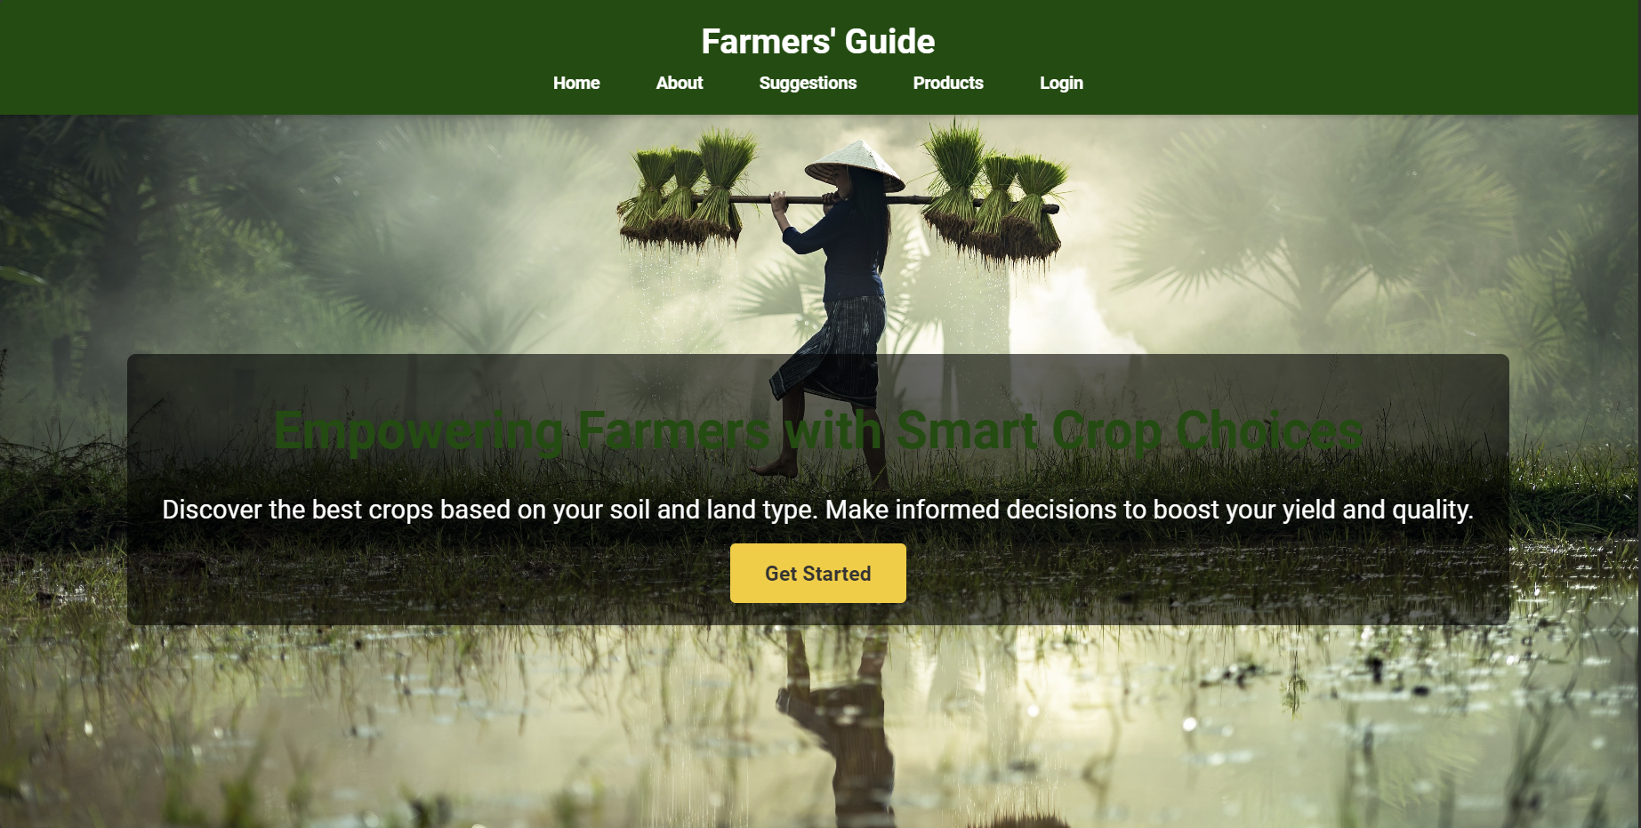

**ABOUT PAGE**

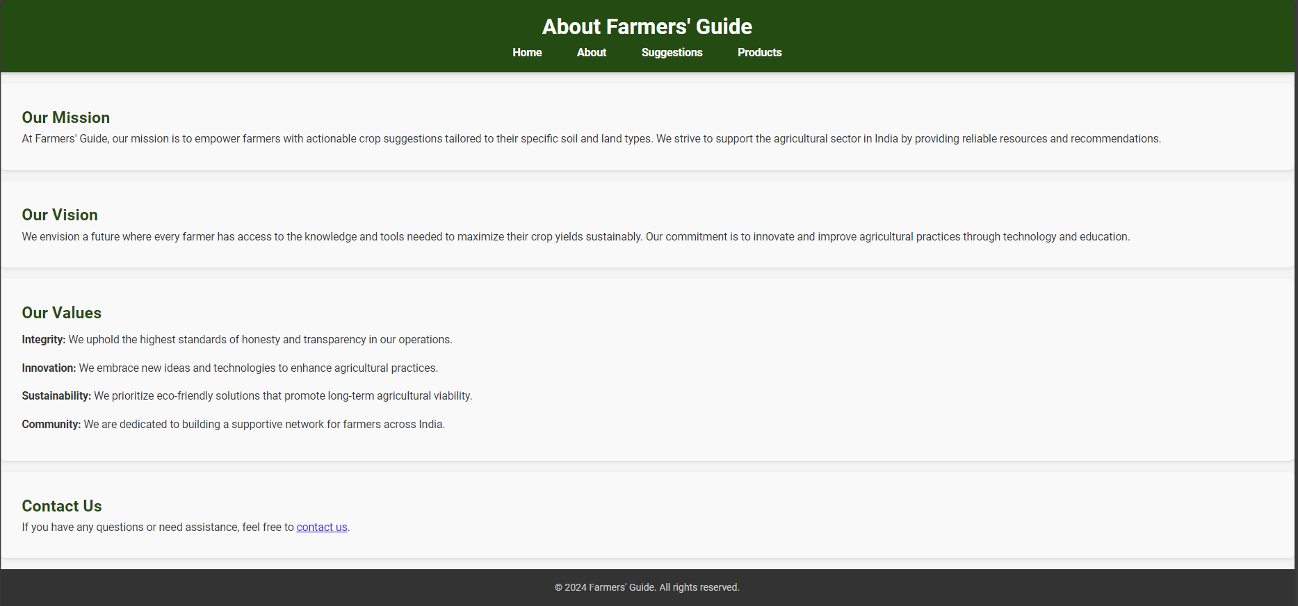

**SUGGESTIONS PAGE**

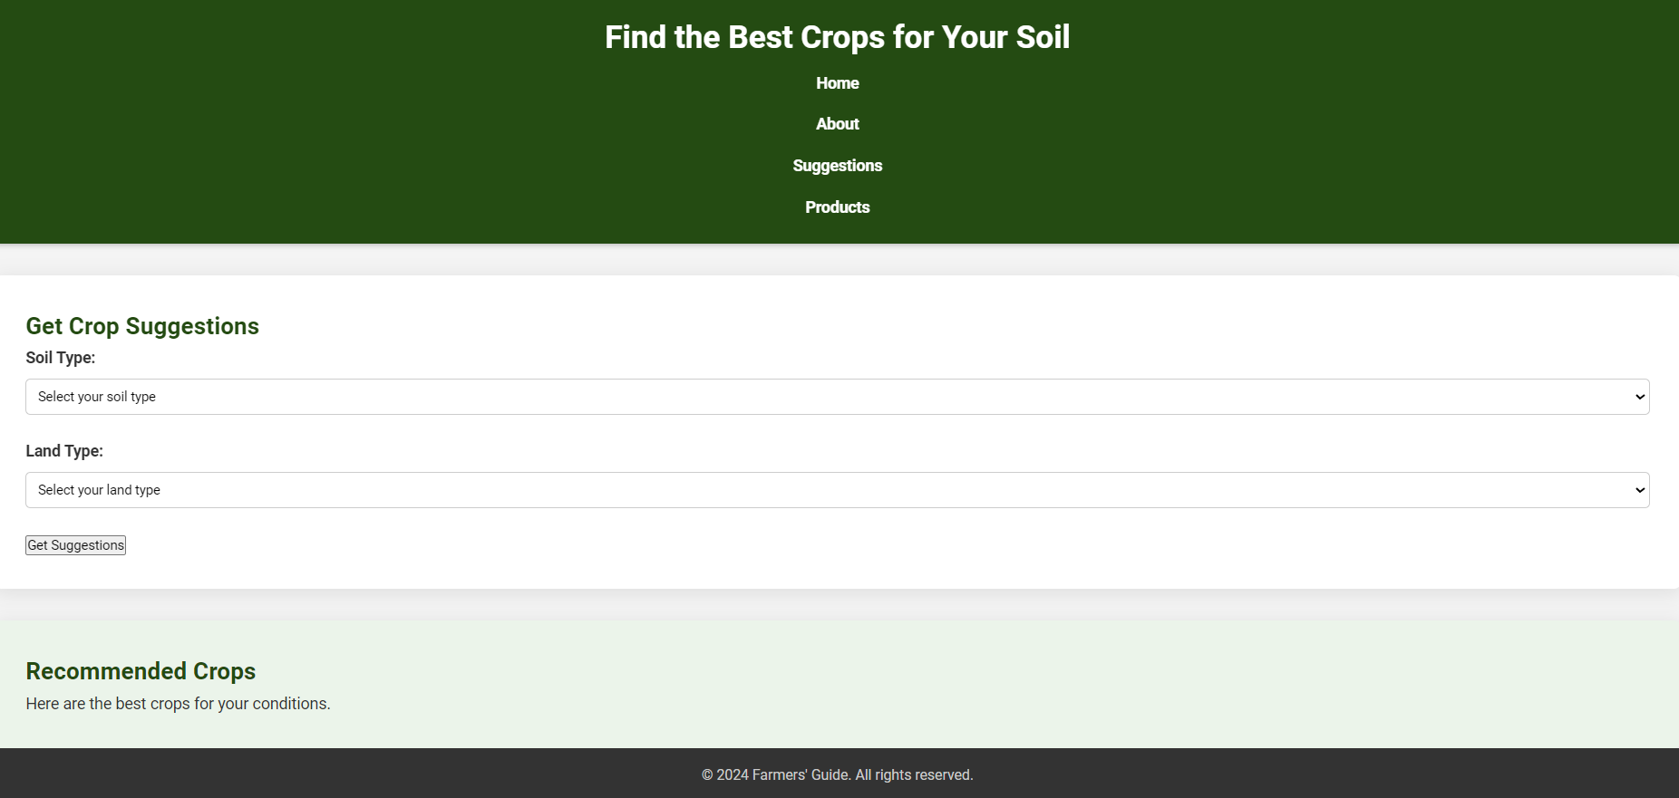

**PRODUCTS PAGE**

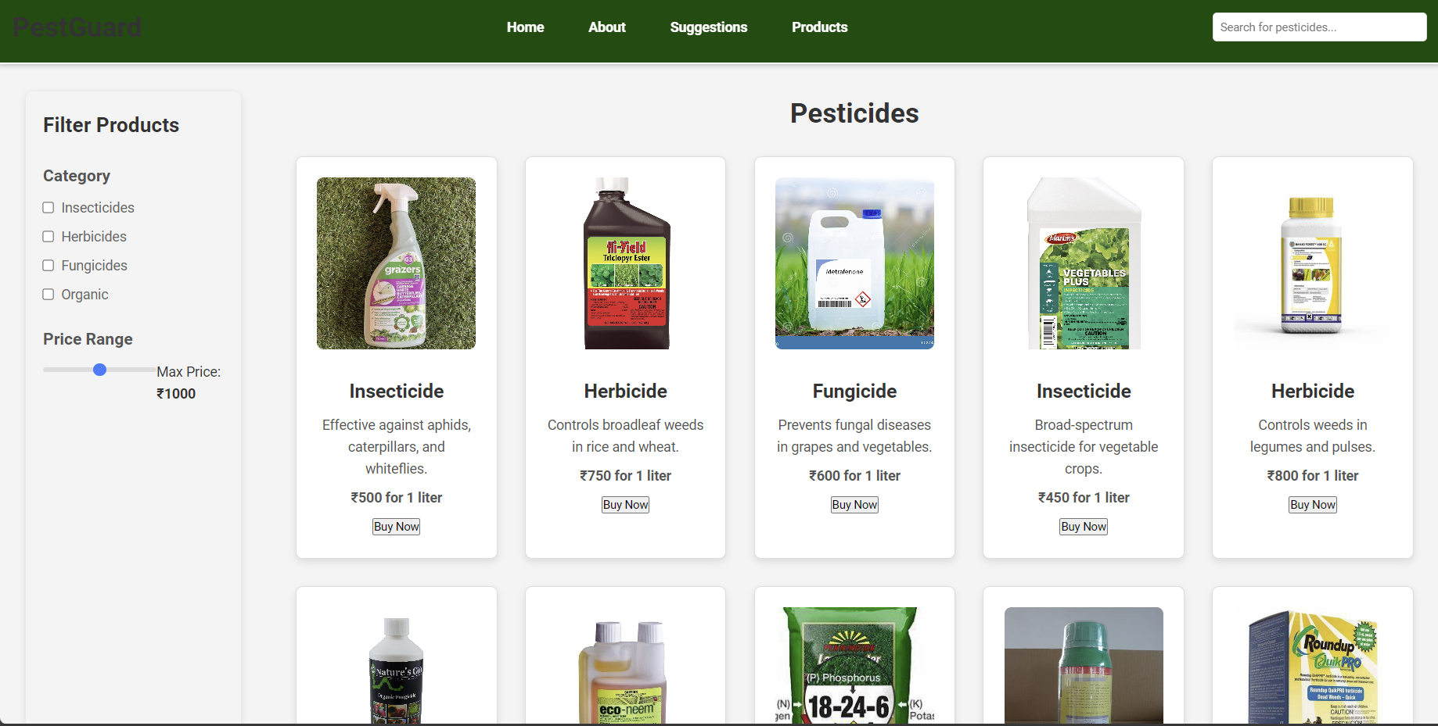

**LOGIN PAGE**

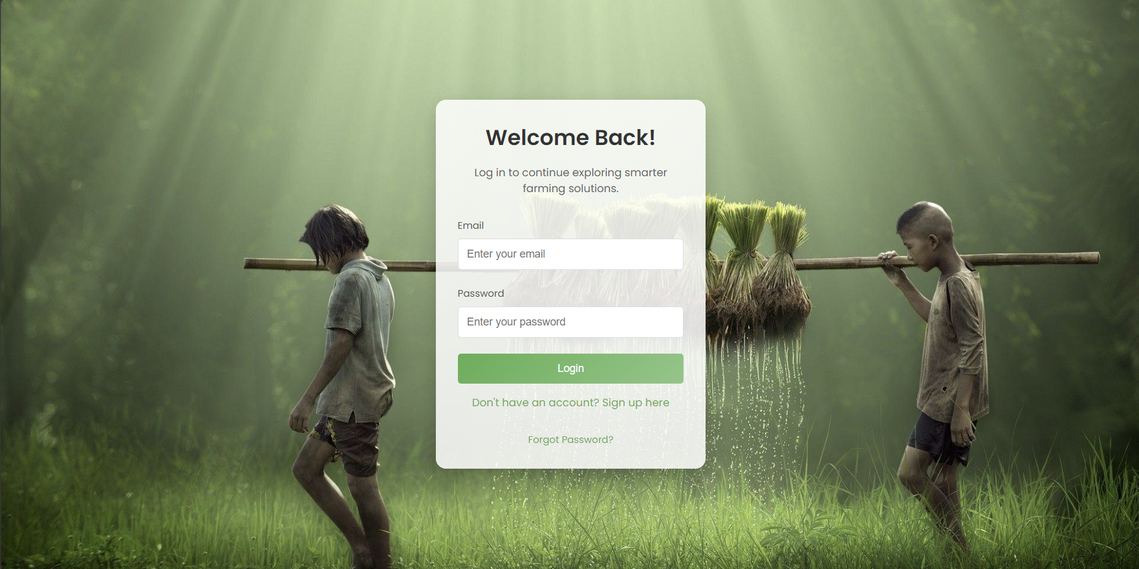

**CONCLUSION**

In conclusion, **Farmers' Guide** aims to be a transformative tool for farmers, providing them with the resources and insights needed to thrive in the modern agricultural landscape. By offering personalized crop recommendations, detailed information about soil types, and access to vital agricultural products, the platform empowers farmers to make data-driven decisions. This helps improve crop yields, reduce costs, and promote sustainable farming practices. With its innovative features and commitment to supporting farmers across India, **Farmers' Guide** paves the way for smarter, more efficient farming, ensuring long-term prosperity for the farming community